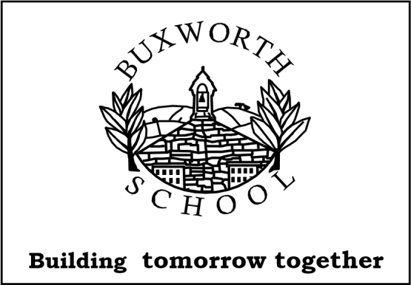
Buxworth Primary School,
Station Road,
Buxworth, High Peak.
SK23 7NJ
Tel: 01663 732426

email: info@buxworth.derbyshire.sch.uk
website: www.buxworthprimaryschool.org.uk

Headteacher: Mr Paul Bertram N.P.Q.H.
Dear Parents and Carers,
We are excited to inform you that the Year 1 and 2 children will be going on a school trip to Jodrell Bank Observatory on Wednesday 24th June 2026.

During the visit, the children will take part in a range of fun and educational activities linked to space and science which links to the final topic of the year ‘Outer Space’. They will explore the interactive exhibitions, where they can learn about planets, stars, and how scientists study space. The children will also have the opportunity to see the famous Lovell Telescope and find out how it is used to look deep into space.
As part of the trip, pupils will:
- Take part in hands-on activities designed for younger learners
- Learn about the solar system and space exploration
- Enjoy a short, child-friendly show or talk about space
- Explore the outdoor areas and spot different features around the site
This trip supports our current learning in science and will help to bring the topic to life in an exciting and memorable way. It also encourages curiosity, questioning, and a love of learning about the world beyond Earth.
Please ensure your child comes to school wearing their uniform and suitable footwear, with a waterproof coat in case of rain. They will be given a packed lunch organised by school (unless arranged otherwise).
We will set off once the children are registered at 9am and be back in time for the end of the school day.
The cost of the trip will be £26.32 per child.

Please complete consent and payment via Parent Pay. In line with our Remissions and Charging Policy, the trip going ahead will be dependent on collecting enough voluntary contributions.

If you have any questions, please do not hesitate to contact us.
Thank you for your continued support,
Mrs Tamkin

