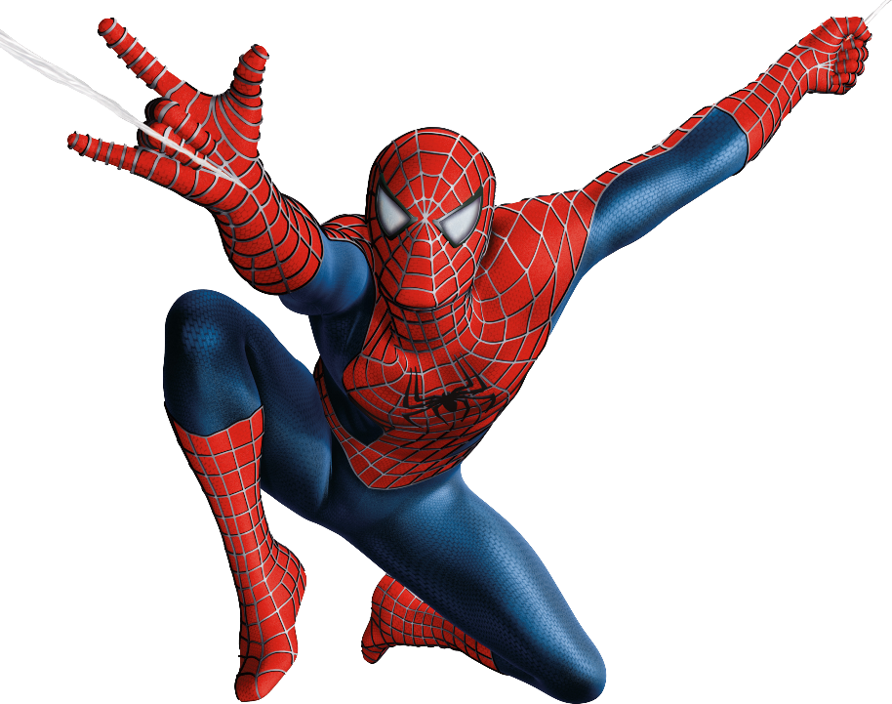
Superhero end of term Party!

At the end of the term to celebrate all the children’s hard work we are going to have a superhero party! The children will have the opportunity to come into school on Thursday 27th March as their favourite superhero (this could be one they have made up themselves) and play some games, sing and dance. Leading up to this, they will organise and plan the games and activities, write invitations to their class mates and design a wish list for their ideal superhero menu!

Costumes are optional, homemade outfits are also encouraged!

This will take place in the afternoon but children can come into school wearing their costumes all day if they wish.

