Communication and Language
- Use language to imagine and recreate roles and experiences.
- Use talk to organise sequence and clarify thinking, ideas, feelings and events.
- Hear and say initial and final sounds in words, and short vowel sounds within words.
- Link sounds to letters, naming and sounding the letters of the alphabet.
- Use their phonic knowledge to write simple regular words and make phonetically plausible attempts at more complex words.
- Explore and experiment with sounds, words and texts.
- Retell narratives in the correct sequence, drawing on language pattern of stories.

Splendid Skies
Spring 1 2025

Physical Development
- Fine motor skill development through play dough and manipulation activities.
- Daily Mile, Wake and Shake and Cosmic Yoga.
- Ball skills, gymnastics and using apparatus.

Maths
Pupils will continue to develop their subitising and counting skills and explore the composition of numbers within and beyond 5. They will begin to identify when two sets are equal or unequal and connect two equal groups to doubles. They will begin to connect quantities to numerals.


Understanding of the World
What can we find beyond the sky? What’s in Space and how will we get there? Which planet do we live on? What makes Earth special? What would it be like to visit the moon? How does the moon affect the Earth? What are stars? Which star is the most important for our planet?

Texts
Whatever Next – Jill Murphy, Roaring Rockets by Tony Mitton and Ant Parker, Beegu by Alexis Deacon, Man on the Moon (a day in the life of Bob) by Simon Bartram, Aliens Love Underpants by Claire Freedman and Ben Court, I’m Coming to Get You by Tony Ross, Here Come the Aliens by Colin McNaughton, We’re Off to Look For Aliens by Colin McNaughton Laura’s Star by Klaus Baumgart, How to catch a Star by Oliver Jeffers and non fiction texts.
R.E
Where Do We Belong?
How do we show respect for one another? How do we show love/how do I know I am loved? Who do you care about? How do we show care/how do I know I am cared for? How do you know what people are feeling?
P.S.E.D
Getting on and falling out;To think of ways to sort things out when we don’t agree.To express feelings when angry. To make myself feel better when angry.

Activities
Making telescopes and rockets;
Making gloopy space pictures and representations of the Earth;
Planning a trip to the moon like Baby Bear in Whatever Next.
Making space biscuits
Plus lots more.

Safeguarding
- How to keep safe in the dark. Learning about keeping safe from strangers.

Forest School
Knot tying
Den Building
How to keep warm in cold climates
Dressing appropriately for the weather
Our environment in Winter
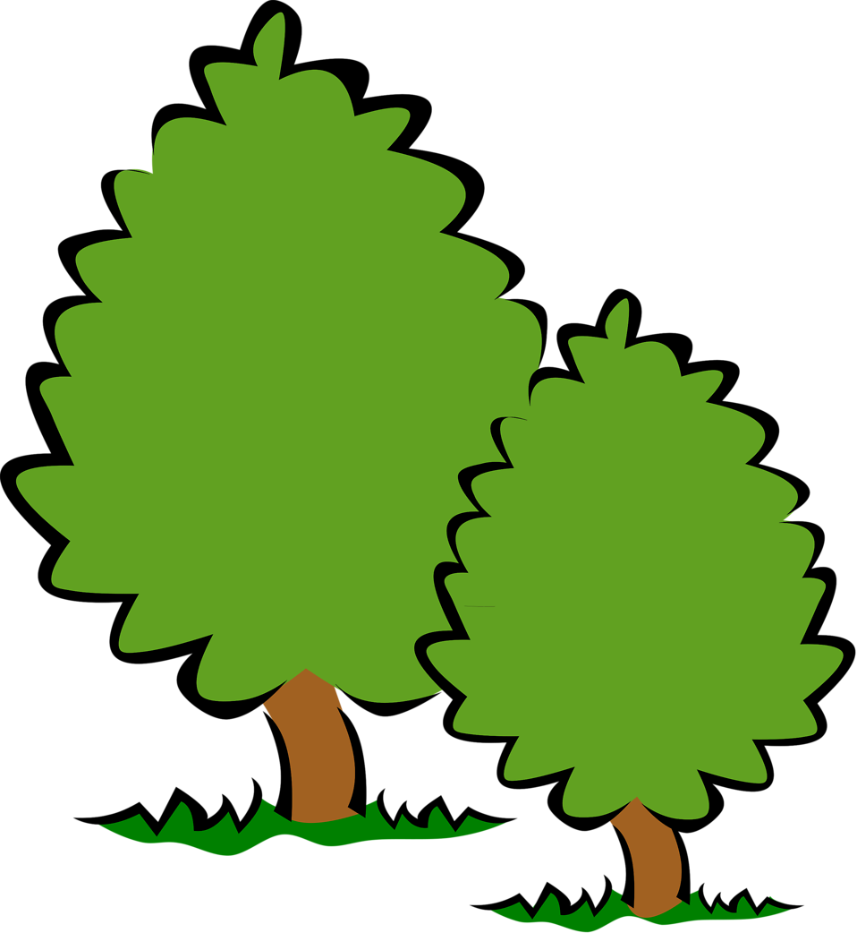

English
- Building on Phase 2 phonics; using to apply their knowledge when writing.
- Learning 2 letter digraphs in Phase 3 phonics. Learning to read and spell high frequency and tricky words.
- Starting to write captions and sentences. Writing in different genres- lists, information facts, posters, letters, stories and addresses.
- Reading books more fluently.

Communication and Language Speaking
40-60m
• Extends vocabulary, especially by grouping and naming,
exploring the meaning and sounds of new words.
• Uses language to imagine and recreate roles and experiences
in play situations.
• Links statements and sticks to a main theme or intention.
• Uses talk to organise, sequence and clarify thinking, ideas,
feelings and events.
• Introduces a storyline or narrative into their play.
Early Learning Goal
Children express themselves effectively, showing
awareness of listeners’ needs. They use past, present
and future forms accurately when talking about events
that have happened or are to happen in the future.
They develop their own narratives and explanations by
connecting ideas or events.
Communication and Language Understanding
40-60m
• Responds to instructions involving a two-part sequence.
Understands humour, e.g. nonsense rhymes, jokes.
• Able to follow a story without pictures or props.
• Listens and responds to ideas expressed by others in
conversation or discussion.
Early Learning Goal
Children follow instructions involving several ideas or
actions. They answer ‘how’ and ‘why’ questions about
their experiences and in response to stories or events.

The Buxworth Bees are the golden threads that will run through all our learning and activities:
Be compassionate, respectful, trustworthy, thankful, friendly, resilient, enterprising and aspiring.


