Books this term

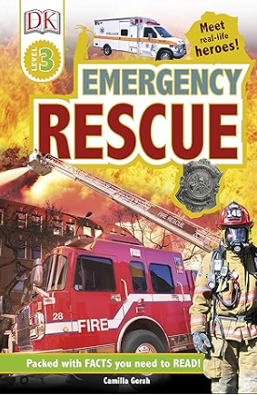
We will be reading a non-fiction book called, ‘Emergency Rescue’ where we will be studying real life rescue missions from the people who help us topic.

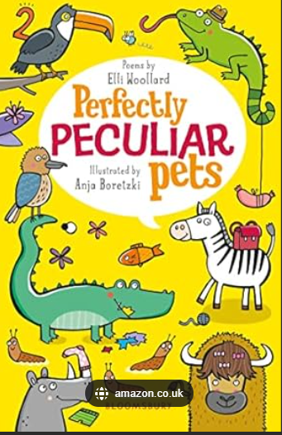
Horse Chestnuts will also be reading a poem a day taken from the book:
Perfectly Peculiar Pets!

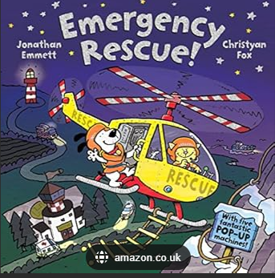
We will also be reading a fiction story also titled ‘Emergency Rescue’ to give us inspiration to write our own narratives, poems, news reports, recounts and letters about The Emergency Services.

We will make comparisons between the fiction and non-fiction books.

As well as these books, the children will be reading a wide range of different texts this topic through reading comprehensions, online stories and during whole class guided reading sessions as well as the books that are included here.

