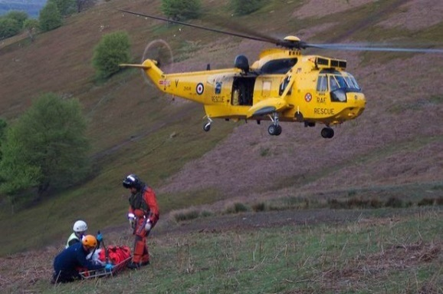
Welcome To The New Term!
Kicking the new term off with some exciting visits from a Mountain Rescuer and a PCSO, where the children will have the opportunity to meet and ask questions as well as learn about the roles they play in our community. There is also a class trip to Buxton Fire Station on 30th January! More details to follow!

ENGLISH - After encountering a ‘classroom crime scene’ involving a mischievous bear, the children will write their own police style report on what happened! Children will study the format of how news is represented in newspapers and make their own newspapers based on historical events taken from our History topic this term: Grace Darling. After carrying out their own research, they will also create a ‘fact file’ all about the various emergency services available.

GEOGRAPHY
We will use Google Earth – Grace Darling - Locate Lindisfarne and follow her journey to the rescue. The children will be studying geographical elements of the seaside coast. We will look at mountain rescue cases carried out at various coastal locations!

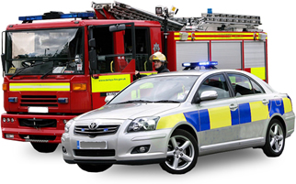
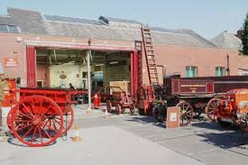
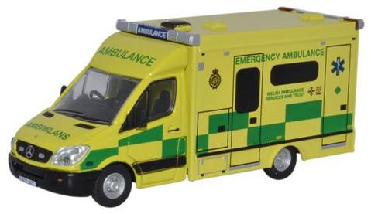
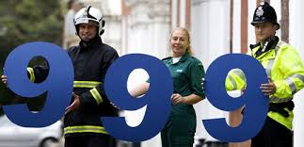

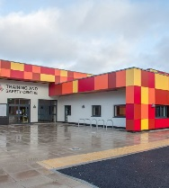

Emergency Services
SCIENCE
Our topic this term is Everyday Materials and their properties.
The children will look at why various objects are made from a variety of different materials and their uses in greater depth.
Study at different types of materials used in emergency situations.
ART

We will be studying aspects of colour and shape – use of colour wheels
Knowledge of contrast and complementary colours.
The children will get the know the term abstract and explain features of an abstract painting.

We will look at artists such as Mark Vaux, Percy Wyndham Lewis, Helen Saunders & Kandinsky.

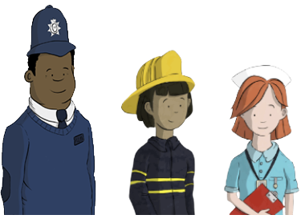
HISTORY

In history we will delve into events current and past on various Mountain Rescues. We also have our own real life Mountain Rescuer visiting the school to give the children a real experience of what to expect!

We will study the lives of significant people including Mother Theresa and Grace Darling and make comparisons of aspects of life in different periods.

We will also explore significant people in own locality e.g. Robert Peel and the role he played in the development of the police force.

