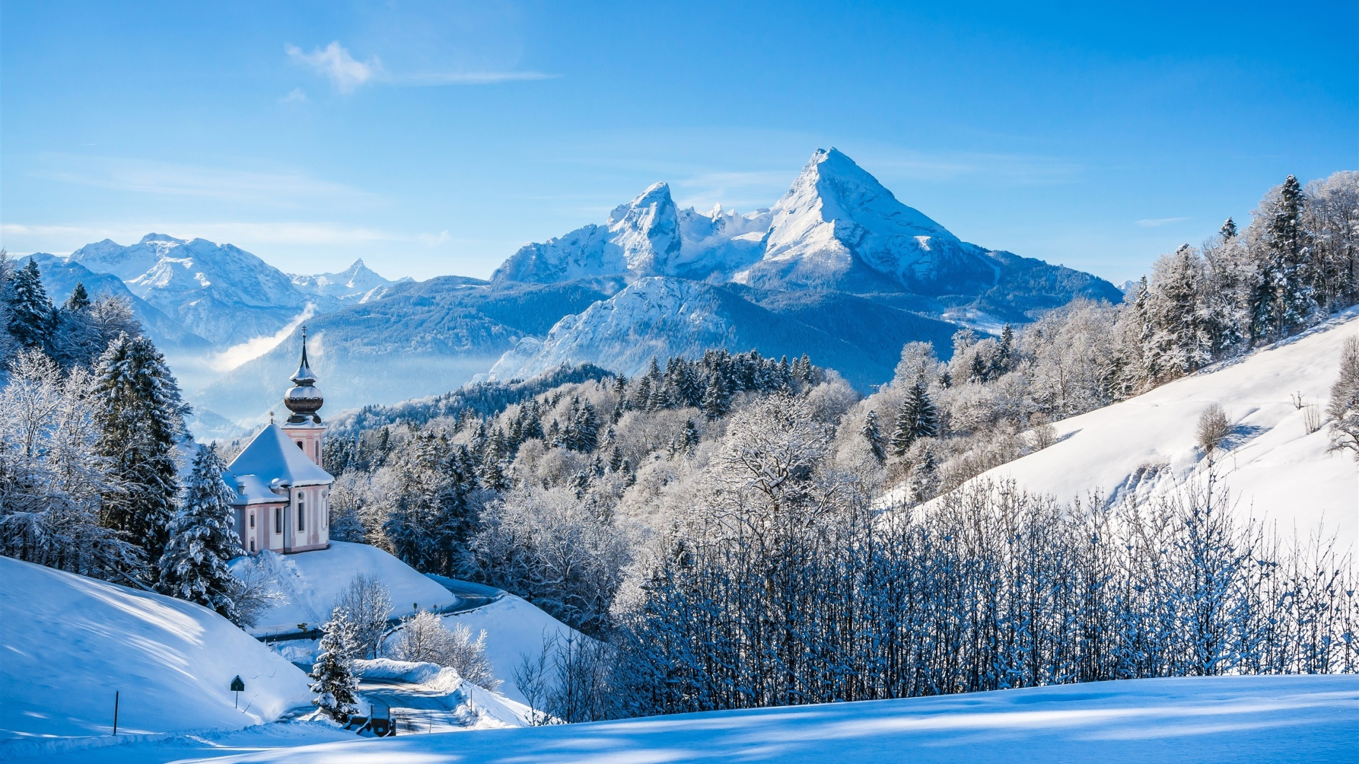
Art and D+TWe will be studying the artisits: Monet, Van Gogh and Metzinger and observing their city and garden scapes. Children will be asked to create their own outdoor scene as well as drawing their bedroom as part of a home learning task.
Welcome to the new term!
This term, the children will be reading and writing all about the world of Narnia in The Lion, The Witch and The Wardrobe! We will also compare snowy settings to this and look at The Snow Queen and Frozen!
Home Learning!
Spellings will resume next Monday so please help your child practise their new words each week. They will get new spellings on a Monday and have a week to learn them. A good technique is look, cover, write check! They could also say them out loud or write them in a sentence.
Please continue to read with your child as often as possible as it has shown to help children develop their language and cognitive skills.
I will send out times tables for children to practise (they need to be familiar with 2s,3s,5s and 10s) this term so please help your child complete this as they can earn extra class house points (dojos) for any extra work.
Geography
Our topics this term will look at oceans and continents using atlases and globes. We will be making our own papier mâché globe and writing a travel brochure to help us choose a holiday destination!
English
The children will be learning how to plan and build their own stories using a story mountain. They will look at settings, characters and plot to introduce KS1 to how to write a great narrative!
Winter Wonderland
Maths
The Horse Chestnuts will be closely following our Power Maths Scheme, which is a mastery approach to learning. The year 1s will be looking at: shape, addition and subtraction within 20, numbers to 50 and weight and volume.
Our year 2s will be learning: multiplication and division, statistics, length and height, shape and fractions.
PE – Gymnastics
The children will be learning how to perform tucks, pikes, turns and twists and be putting their skills into a sequence of movements with music!
Computing
Children will use technology safely and respectfully in the context of searching for appropriate images online. They will learn how to safely search for images online
Science
Living things and their habitat and Seasonal Change! They will learn how to identify habitats, name plants and animals who live there and describe how animals obtain food.
History
The Children will be learning about famous Explorers: Ibn Battuta, Matthew Henson and make comparisons between those explorers and the more recent explorer: Felicity Alston. We will also look at an interview by Neil Armstrong and ask why these people are significant.

