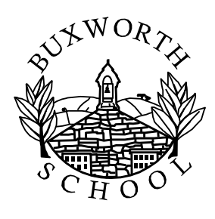

Dear Parents,

Welcome back to school after enjoying a lovely festive break

Our topic this term is Winter Wonderland!

A few routines for the week:

- The school day – Horse Chestnut’s school day will run from 08:55 to 15:10.

- PE will be Friday afternoons which means your child should come to school wearing their PE kit on those days. Swimming will start from January on a Wednesday. This will be from 17th January and run until the summer.

- Forest School will take place again on Tuesday afternoons so children will need to come to school in their outdoor kit. With winter upon us, the children will enjoy some fantastic outdoor learning opportunities however please take account of possible wet/cold weather and choose weather-appropriate clothing for your child.

- Reading books: We will listen to children read frequently throughout the week and they will have books allocated at the correct reading level. They will continue to be given two reading books (one is a challenge book and one set at a level with which they should be fairly fluent). They will be sent home on their reading day (noted at the top of this page) please get your child to read as often as possible. They will be changed if your child has become fluent and competent enough, they may need to keep practising for another week if not.

- Spellings will be set on Mondays. Please help your child by practising these at home (I will put spellings on the class webpage as well as sending home a list each week)

- Homework: Throughout the week your child will be expected to learn their spellings and times tables(found on the website under home learning), and should try to read every evening. There will be an art based project this term relating to the artists we will be studying so watch this space! The children can earn extra dojos if they complete extra home learning tasks.

- Water bottles can be brought into school each day. Please label these and ensure they contain water, not juice.

Again, please do not hesitate to contact me with any questions or concerns.

Kind regards, Mrs Tamkin

