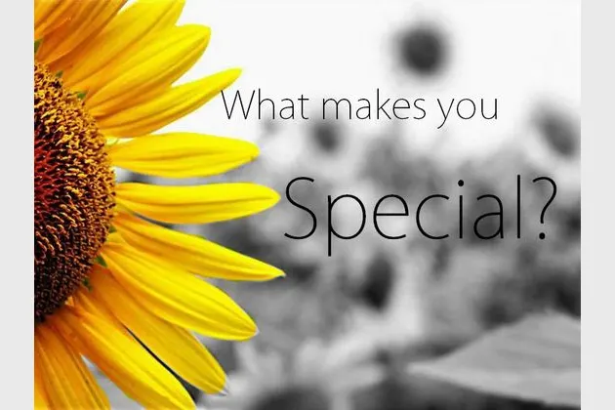
Science – based around our topic.
*Living Things.
*Observing differences and changes over time.
*Senses.
*Healthy bodies.

Maths (Power Maths)
Year 1: Addition and subtraction within 20, Numbers to 50, Length & Height, Weight & Volume
Year 2: Addition, Subtraction, Multiplication and Division up to three digits. Length & Height, Properties of shapes, Fractions, Position and directions.
*Alongside this we will have a continued focus on key maths skills such as times tables and number bonds.
Topic-based learning:
Music – Creating sounds, improvisation, beat & rhythm, notation.
ICT – Web navigation, using cameras and editing photographs, understanding coding.
History & Geography – Special Places, maps and routes, timelines and changing over time.
PSHE – based on Project25 and covering areas including keeping safe, medicines and dangerous substances, road safety, growing up.
Art and DT
*Collage*Self-portraits*The colours of Van Gogh*Moving People (based on Keith Harding)*Clay Faces*Patterns*

English (based around the following texts)
Traction Man – Descriptive writing.
Room on the Broom – Narrative writing and storytelling.
Frightened Fred – Leaflets and describing thoughts & feelings.
Autumn Leaves – Poetry.
*related and supporting texts and materials will also be used to teach composition, spelling, punctuation and grammar, and comprehension. We will also focus on building vocabulary and writing at increased length.
Safeguarding
As well as a continued focus around awareness of COVID-19 considerations, we will also be thinking about safety when travelling both locally and more widely.

Other information:
- PE will be on Tuesdays and Fridays.
- Forest Schools Wednesday afternoons.
- Spellings to be set/tested on Mondays (they will be on the class page).
- Reading books will be sent home (and returned to school) on Wednesdays.

Project 25.
We will be using the Project 25 values in all of our learning.
The values of compassion, friendliness, aspiration, resilience, trust, respect, thankfulness, being environmentally aware, learning about STEM and learning with an entrepreneurial spirit will feature throughout the learning.

R.E:
Faiths and beliefs around the world.
Learning about ‘special’ places and our ‘special’ world.
Stewardship – animals and the environment.

