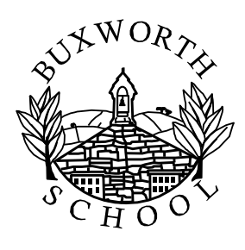

Dear Parents,

Welcome back to school after what I hope has been an enjoyable summer break. I also hope that, like me, you are looking forward to hearing from your children about the fantastic learning opportunities coming up over the next academic year. the difficulties of the last year or so. A lot of thought and planning goes into ensuring that everybody is kept safe and happy in school and that the children able to really enjoy their learning at Buxworth Primary School.

I would just like to outline some of our Horse Chestnuts Class routines from now up until the end of 2023, and also provide you with an overview of what we will be covering from the National Curriculum. If you have any queries, or wish to discuss anything regarding your child, please don’t hesitate to contact the school.

----------------------------------------------------------------------------------------------------------------------------------------

Horse Chestnuts class looks forward to welcoming our Year One children, and of course welcoming back our Year Two pupils. I (Mr Tupman) will lead teaching and learning in the class throughout the week, ably supported by Mrs Povey and also our specialist PE and support staff from across the school.

Our topic this term is What Makes Me Special. During this topic, children will have the opportunity to take on all sorts of exciting challenges and activities from across the curriculum and also develop their skill-set by working around our Project25 values. Full details of this term’s learning are on the curriculum plan.

A few routines for the week:

- The school day – Horse Chestnut’s school day will run from 08:55 to 15:10.

- PE will be on Wednesday and Friday afternoons which means your child should come to school wearing their PE kit on those days – please see the website for information on the correct school PE kit. Please could the children also have a labelled spare set of clothes to keep in school in case they need to get changed.

- Forest School will take place on Tuesday afternoons so children will need to come to school in their outdoor kit. With Autumn upon us, the children will enjoy some fantastic outdoor learning opportunities however please take account of possible wet/cold weather and choose weather-appropriate clothing for your child.

- Reading books: We will listen to children read frequently throughout the week and they will have books allocated at the correct reading level. Additional reading books will be sent home each Wednesday so should be returned to school the following Wednesday so that new books can be sent home. Please listen to your child ready daily.

- Spellings will be set on Wednesdays and will be practised in the classroom each day ready for a knowledge check the following Wednesday. Please help your child by practising these at home (I will put spellings on the class webpage as well as sending home a list each week)

- Homework: Throughout the week your child will be expected to learn their spellings and times tables, and should try to read every evening. Project based homework related to the curriculum will be set as appropriate and we may also ask for items such as photographs or favourite to be sent or brought into school to support learning.

- Water bottles can be brought into school each day. Please label these and ensure they contain water, not juice.

Again, please do not hesitate to contact me with any questions or concerns.

Kind regards,

Mr Tupman

