What Makes Me Special Topic Challenge
All of the children have made an amazing start to the school year, so far learning about personal timelines, the human body and animal classifications, and about how to keep themselves safe online (as well as becoming coding wizzes on the ipads!).
We hope everyone has been finding the time to read and practice spellings daily and, as an extra homework task, we challenge the children to contruct their family tree. An example of how it might look is shown below.
Of course I understand that not all family situations lend themselves to a traditional family tree. If this is the case, I would suggest a ‘family circle’ of al the people, pets etc who are close to your child.
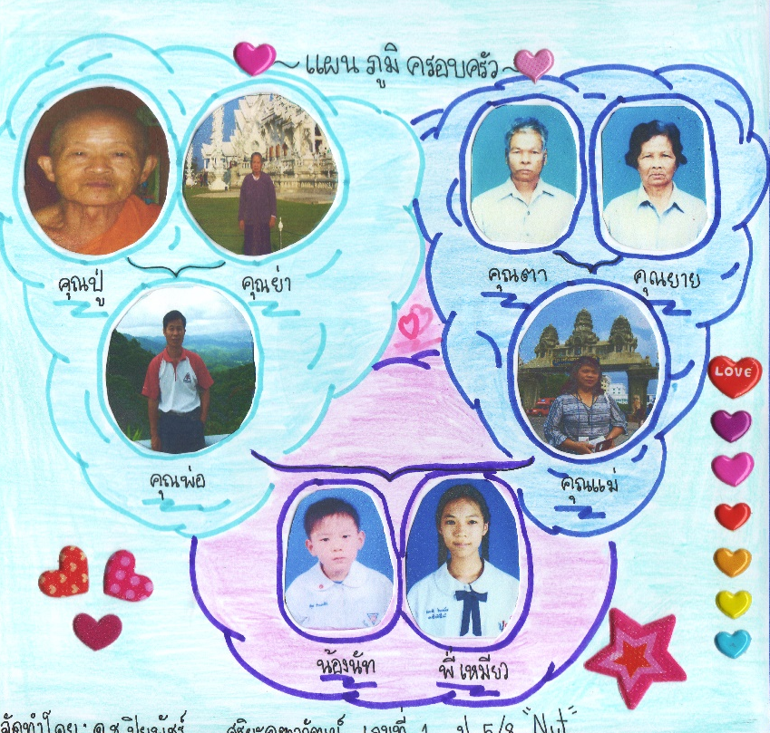
We look forward to seeing and discussing the children’s work in class the week after next so please bring family trees/circles in by Friday 13th October.

Regards,

Mr Tupman

