The Story Orchestra: The Magic Flute By
Katy Flint
Discover the sorcery of The Magic Flute in this musical retelling of the opera - push the button on each beautiful scene to hear the vivid sound of an orchestra playing, and singers singing, from Mozart's score.

As you journey through the magical scenes, you will press the buttons to hear 10 excerpts from the opera's music. At the back of the book, find a short biography of the composer, Mozart, with details about his composition of The Magic Flute

Vetman and his Bionic Animal Clan By Noel Fitzpatrick
Join Vetman, Imogen, Findlay and a whole cast of incredible bionic animals as they save animal companions everywhere from the evil plans of The Man With No Name! An amazing animal adventure for readers aged 7- 11 from Noel Fitzpatrick, Channel 4's SUPERVET.
Vetman lives in a cottage outside a sleepy English village, where nobody realises that he's saving animals in incredible, bionic ways - except the animals themselves, of course!
But trouble is brewing... because Vetman's old foe, The Man With No Name, has set up camp nearby and plans to poison dogs and cats across the land.
Every day, you use the ultimate supercomputer ... your brain! Join Little House of Science on an access-all-areas tour of the body's brilliant command centre. Using fun exercises and experiments that are easy to do at home, and presented with simple, easy-to-follow illustrations, This Book is Full of Brains is an awe-inspiring guide to this remarkable organ. Discover the gruesome history of neuroscience, check out the inner workings of animal brains and find out all about the remarkable things the brain can do. How fast can a thought travel? How do senses work? Why do we sleep? Find out the answers to these questions and many,

This Book is Full of Brains

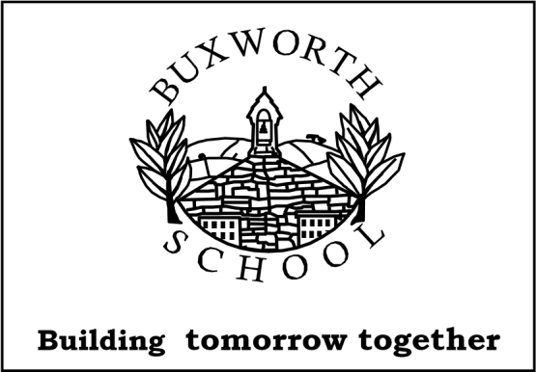

Buxworth Primary Year 1 and 2 Recommended New Reads

Count
By Melvin Burgess

Brandon is a boaster - he says he is brilliant at lots of things. Then he is challenged to count up to ten million. So Brandon starts: one, two, three . . . and before long he is up to one thousand. Everyone around him is bewildered: his friend Waris, his teachers and Miss Hexx, the head.
But Brandon can't stop counting. And the higher he counts, the more everyone takes an interest, when Brandon reaches 30,000 he goes viral, by the time he gets to one million, he has a stadium full of fans counting with him. And then strange, impossible things start happening…

Annabel Karmel's Fun, Fast and Easy Children's Cookbook

This practical cookbook from leading children's cookery author Annabel Karmel is filled with fun, tasty recipes that will help parents inspire young children with a love of cooking, food and healthy eating.
Inside, you'll find everything from Hidden Vegetable Bolognese to Teddy Bear Burgers, as well as nutritionally balanced snacks and sweets like oat and raisin cookies and fruity ice lollies. Recipes include child-friendly versions of food from around the world, such as stir-fries, paella and kebabs.

Fairy Tale Land
By Kate Davies

Fairy Tale Land opens the gates to the magical land where all the fairy tale characters live.
Get lost in this visually stunning, oversized gift book that features all the well-loved stories, and immerse yourself in their enchanting world!
The tales are expertly retold, perfect for bedtime, and each story is followed with an exquisitely illustrated, detailed map of its neighbourhood. You can drop into Hansel and Gretel's cottage, explore the palace from Beauty and the Beast, and dive deep under the sea with the Little Mermaid. What wonderful things can you find in your favourites' homes?




