Communication and Language
- Use language to imagine and recreate roles and experiences.
- Use talk to organise sequence and clarify thinking, ideas, feelings and events.
- Retell narratives in the correct sequence, drawing on language pattern of stories.
- Learn and use new vocab.
- Learning Julia Donaldson songs and performing them.
- Learning rhyming words.
- Making up spells and playing with different words and sounds.

The Wonderful World of Books
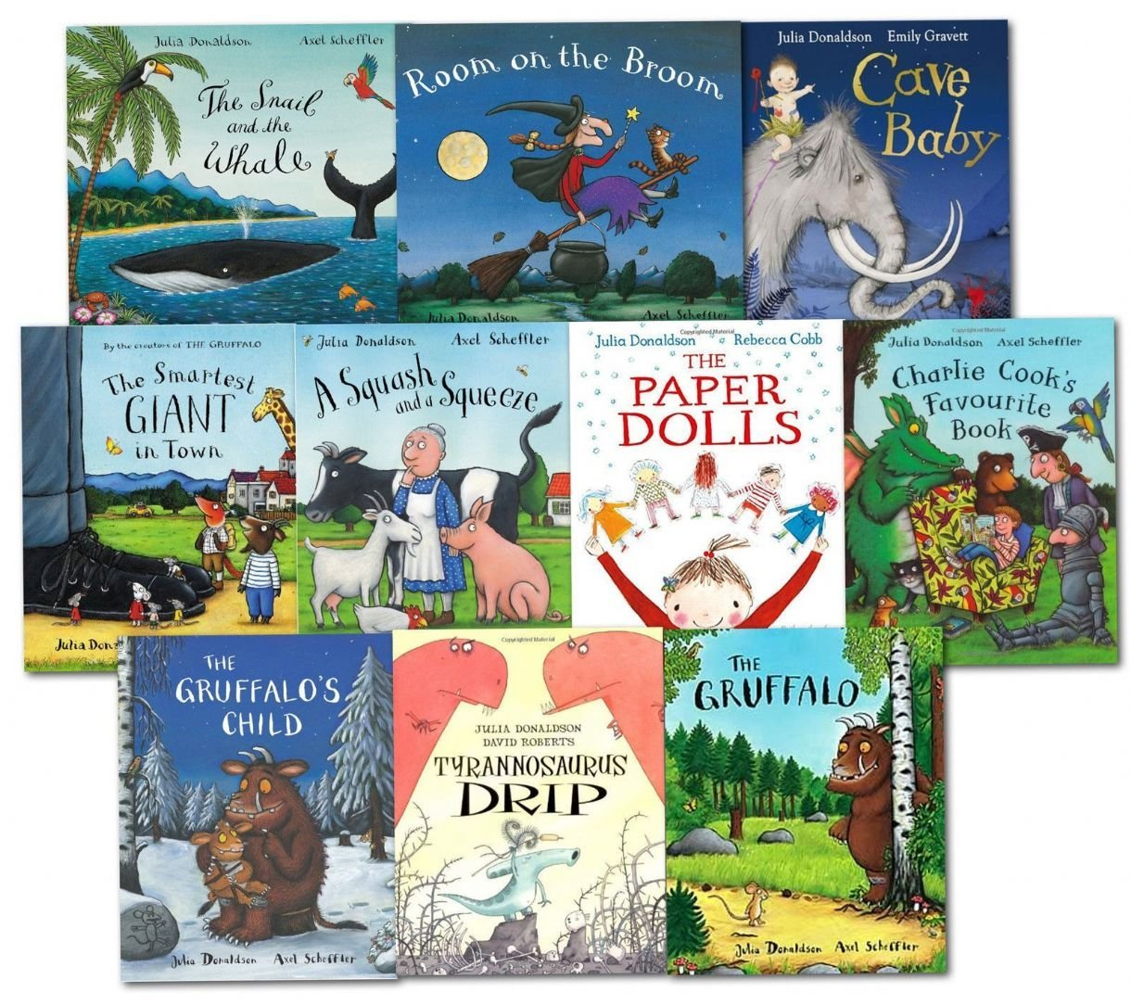
Physical Development
- Athletics skills.
- Body balance, and Coordination
- Daily Mile, Wake and Shake and Cosmic Yoga.
- Practising for sports days.
- Learning to race and compete.

Maths
- Halves, doubles, odd and even
- Counting in 2s,5s and 10s
- Composing and decomposing shapes
- Time
- Money.

Understanding of the World
Identifying parts of a plant
Learning to name garden and wild plants
Identifying common deciduous trees
Comparing our local environment with cities and towns
Comparing our local environment with different parts of the world
Learning about the Amazon Rainforest

Texts by Julia Donaldson
The Room on the Broom, The Smartest Giant in Town, Superworm, Stickman,The Scarecrow’s Wedding, The Gruffalo and What the Ladybird Heard.

R.E Which People are special and why?
Who is special to me and why? How do I show that I love and care?
Who were Jesus’ special friends?
Learn significant stories from The Bible and Koran.
P.S.E.D
How to look after and care for animals.

Activities
Making Gruffalo Crumble
Making up spells and potions
Spaghetti art
Having a Scarecrow’s wedding.

Safeguarding
- Learning about safe plants ad trees to touch. Learning how to keep safe over Summer.

English
- Continuing to write simple sentences and extending it to compound sentences using the conjunctions and, but and because.
- Writing in different genres- lists, information facts, posters, letters, instruction, spells and Wanted posters.
- Reading books more fluently.
- Learning to spell and read tricky and high frequency words quickly.

Communication and Language Speaking
40-60m
• Extends vocabulary, especially by grouping and naming,
exploring the meaning and sounds of new words.
• Uses language to imagine and recreate roles and experiences
in play situations.
• Links statements and sticks to a main theme or intention.
• Uses talk to organise, sequence and clarify thinking, ideas,
feelings and events.
• Introduces a storyline or narrative into their play.
Early Learning Goal
Children express themselves effectively, showing
awareness of listeners’ needs. They use past, present
and future forms accurately when talking about events
that have happened or are to happen in the future.
They develop their own narratives and explanations by
connecting ideas or events.
Communication and Language Understanding
40-60m
• Responds to instructions involving a two-part sequence.
Understands humour, e.g. nonsense rhymes, jokes.
• Able to follow a story without pictures or props.
• Listens and responds to ideas expressed by others in
conversation or discussion.
Early Learning Goal
Children follow instructions involving several ideas or
actions. They answer ‘how’ and ‘why’ questions about
their experiences and in response to stories or events.

The Buxworth Bees are the golden threads that will run through all our learning and activities:
Be compassionate, respectful, trustworthy, thankful, friendly, resilient, enterprising and aspiring.


