Maths
• Subitising within 5• Understanding counting to 20
• Understand the staircase pattern of 1 more and 1 less.
• Comparing sets of objects and numbers.
• Ordering numbers.



Physical Development
As well as continuing with our Daily Mile and developing children’s coordination and core strength we will be learning Gymnastics.
- Rolls, jumps, shapes and balances, travelling and linking actions and movement sequences.

Winter Wonderland
Spring 1
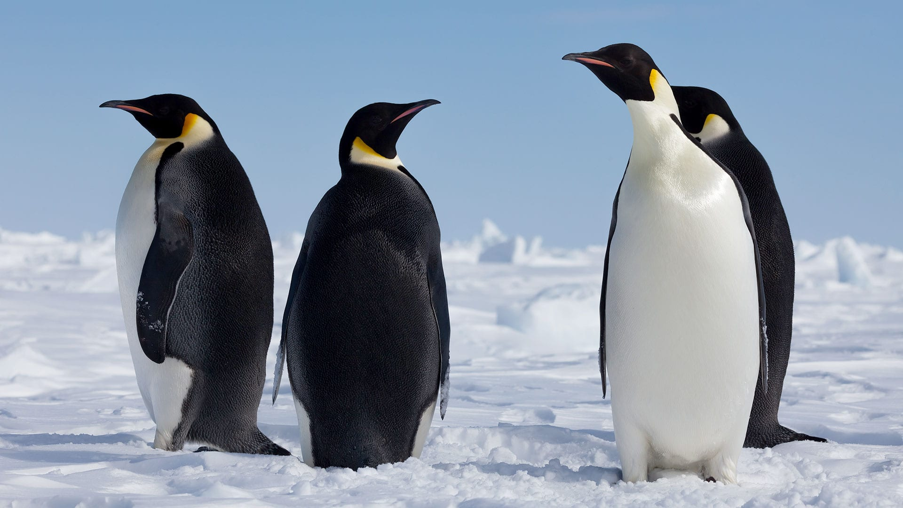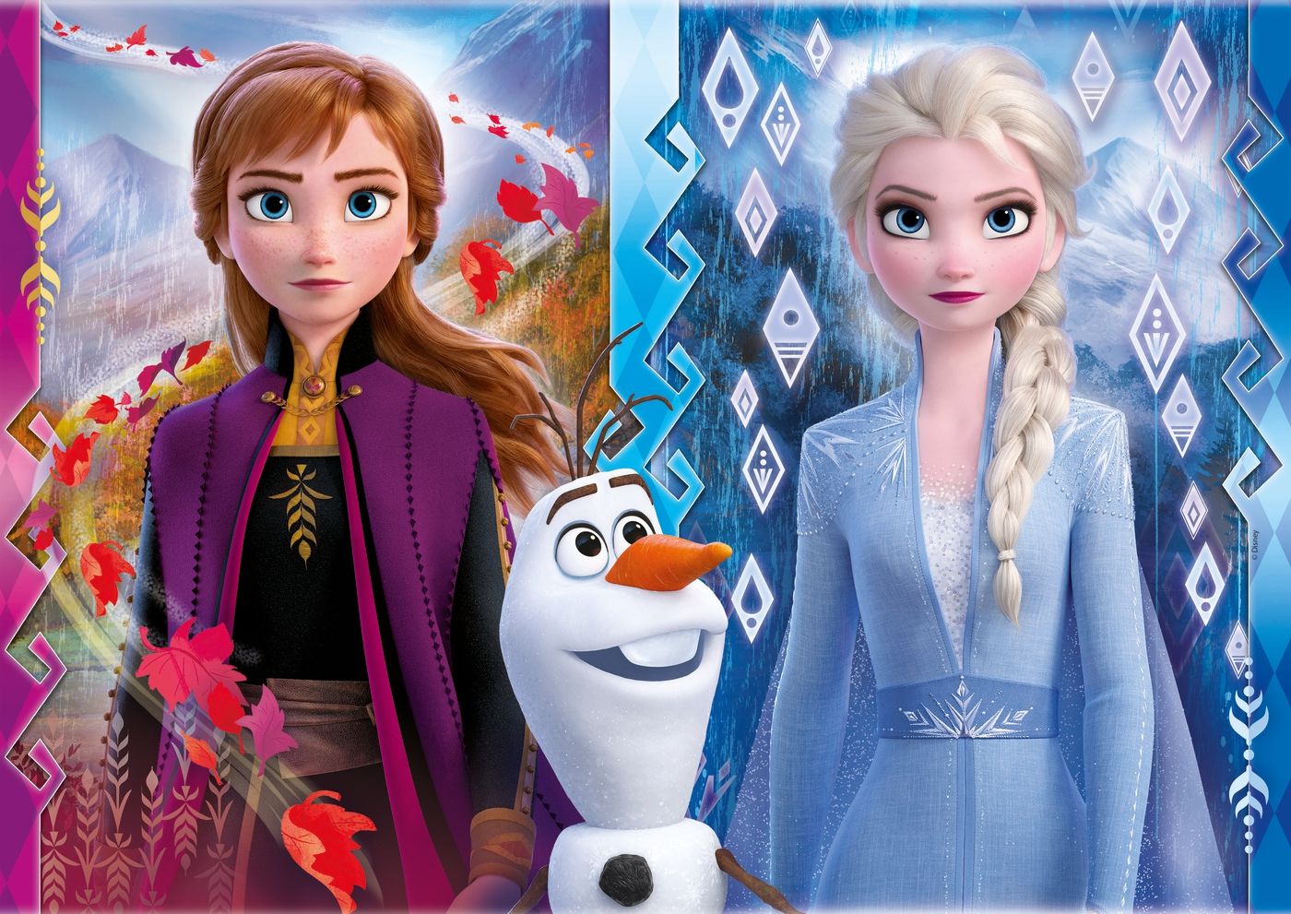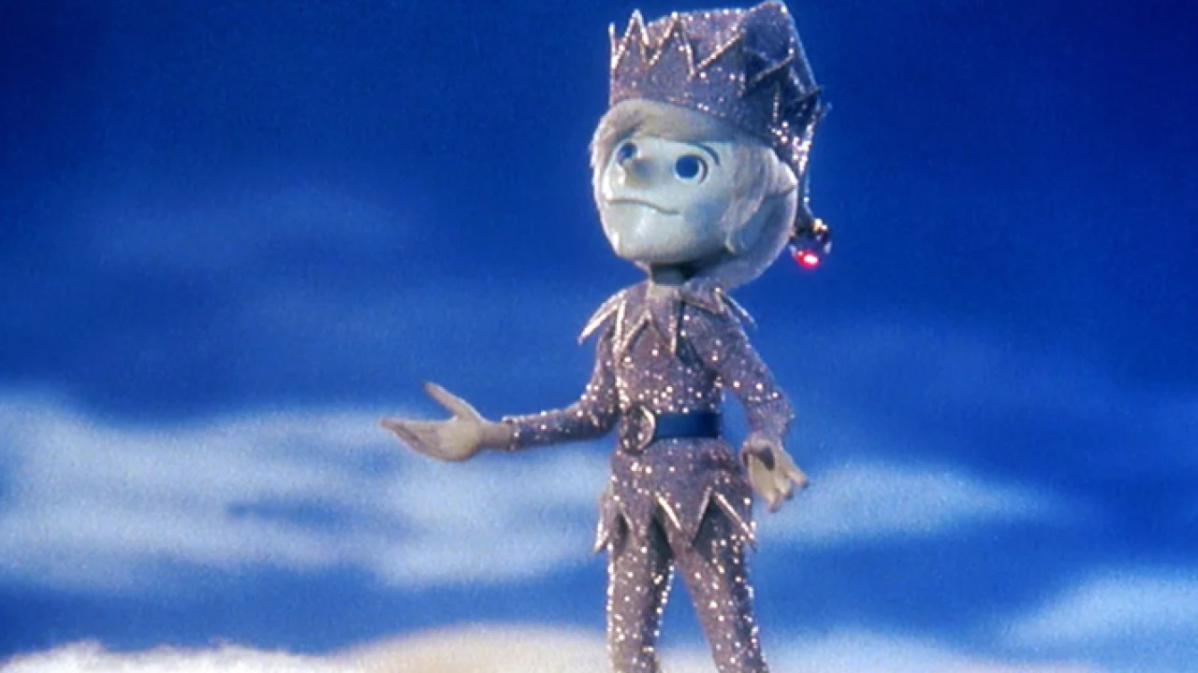
Communication and Language
- Singing songs and joining in.
- Listening to each other’s ideas and responding.
- Listening and responding to stories.
- Develop own narratives and explanations by connecting ideas.

Understanding of the World
Global Citizenship
Religions around the world:Hinduism and Christianity.
The Polar regions of The Arctic and Antarctic and learning about the environmental issues they face.

P.S.E.D/ R.E
This term our unit will be :Where Do We Belong?
We will talk about how we show care and love for one another and how we welcome others in.
We will use religious stories to help us.
See themselves as a valuable individual. • Build constructive and respectful relationships. • Express their feelings and consider the feelings of others.

.
Growth Mindset
- Learning resilience
- Taking on challenges
- Learning the power of ‘Yet.’
.
Activities
Planning, preparing for and enjoying a Polar Adventure.
Learning about Explorers from the past- Ernest Shackleton and Sir Edmund Hillary.
Preparing to hibernate.
Making Frozen cakes and food that will keep us warm .

Literacy
We will be using a variety of animation, fiction and non - fiction texts to help us learn about Winter. These will include the movie Frozen, The Polar Express, Here Comes Jack Frost, The Gruffalo’s Child, Animals in Winter and The Coldest Tundra.
We will be continuing with our daily phonics lessons and learning:
- Phase 3 and 5 phonics; learning 2 letter digraphs and alternative ways to make already known sounds.
- Blending CVC words, reading sentences and learning many High Frequency Words.
- Learning to label, write captions and sentences.

Forest School
Learning how to dress suitably for cold weather.
Making warm drinks and snacks.
Making shelters, practising and learning new knots.
Learning about changes to our Eco Area in Winter.


Safeguarding
How to be warm and safe in cold climates.
Communication and Language Speaking
40-60m
• Extends vocabulary, especially by grouping and naming,
exploring the meaning and sounds of new words.
• Uses language to imagine and recreate roles and experiences
in play situations.
• Links statements and sticks to a main theme or intention.
• Uses talk to organise, sequence and clarify thinking, ideas,
feelings and events.
• Introduces a storyline or narrative into their play.
Early Learning Goal
Children express themselves effectively, showing
awareness of listeners’ needs. They use past, present
and future forms accurately when talking about events
that have happened or are to happen in the future.
They develop their own narratives and explanations by
connecting ideas or events.
Communication and Language Understanding
40-60m
• Responds to instructions involving a two-part sequence.
Understands humour, e.g. nonsense rhymes, jokes.
• Able to follow a story without pictures or props.
• Listens and responds to ideas expressed by others in
conversation or discussion.
Early Learning Goal
Children follow instructions involving several ideas or
actions. They answer ‘how’ and ‘why’ questions about
their experiences and in response to stories or events.

The Buxworth Bees are the golden threads that will run through all our learning and activities:
Be compassionate, respectful, trustworthy, thankful, friendly, resilient, enterprising and aspiring.


