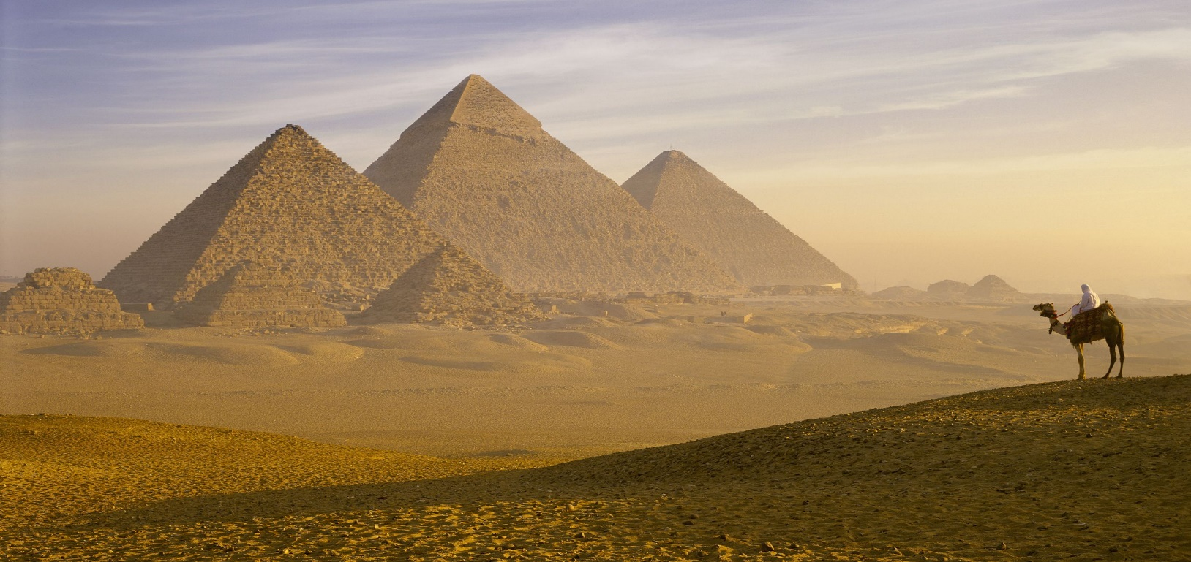
Some of the Class Books we will read and explore this term:

- The Time Travelling Cat and The Egyptian Goddess
- The Egyptian Cinderella
- There’s a Pharoah in our Bath
- The Genius of the Ancient Egyptians
- At Home with the Ancient Egyptians
- The Egyptian Cinderella
- The Curse of the Mummy

