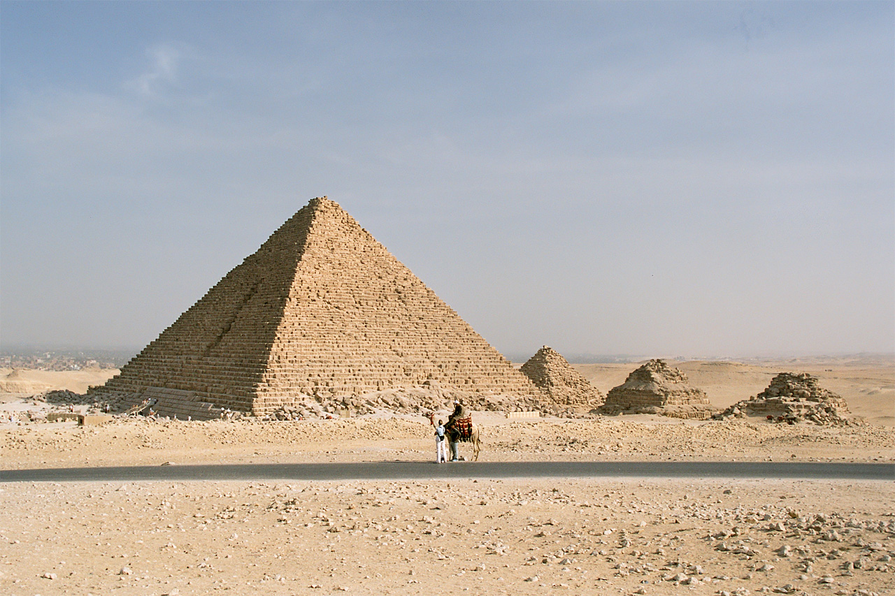
History
We will be studying the time period of Ancient Egypt, specifically where it fits within history. Through this, we will be exploring what life was like for Ancient Egyptian children, tomb and pyramid buildings, mummification, gods, pharaohs and hieroglyphs, amongst other exciting ideas. Our trip to the Manchester Museum on 2nd October will help give children even more context and understanding about this time period! Please see letter for more details. There will also be an ‘Egyptian Day’ – where children can come into school dressed as an Egyptian and enjoy a range of fun activities! Date TBC.

Maths
In Autumn term we will cover the following:
- Review strategies for adding and subtracting across 10
- Learn place value to 100 and apply this to addition and subtraction
- Bridge 100: count on and back in 10s, as well as add/subtract multiples of 10
- Measure length and record in tables
- Represent 3-digit numbers, compare and position them on number lines
All children need to continue to practice their TTRS in preparation for the year 4 multiplication tables check. Please ask if you are unsure of your child’s login details.

Tomb Raiders
Egypt
Autumn Term 2026

Science
This term we will be covering two Science Units.
Light:
- recognising that we need light to see and that darkness is the absence of light
- looking at how light is reflected from surfaces
- recognising that light from the sun can be dangerous and understanding how we can protect our eyes
- investigating how shadows are formed and changed
Animals Including Humans:
- describing the simple functions of the basic parts of the human digestive system
- identifying the different types of teeth and their functions in humans
- understand food chains

English
Spellings:
- Spell words where ‘ou’ makes an /ow/ and a /u/ sound
- Spell words where ‘y’ makes an /i/ sound
- Spell words ending in ‘-sure’ and‘-ture’
- Spell words with the prefix ‘re-’ and ‘mis-’
- Spell words where ‘-ing’, ‘-en’ and ‘-ed’ are added to multisyllabic words.
Look out for your child’s homework. Every Friday they will be given 5 spellings and sometimes a project or activity linked to the topic to complete.
In English lessons, we will be doing lots of decoding and comprehension skills in reading (look out for more information about Accelerated Reader), practicing letter formation and joined handwriting as well as recapping grammar skills learnt so far before introducing some new ones!
English writing examples are as follows:
- fictional stories with a geographical setting (one is set in Africa)
- letter writing based on Howard Crater discovering Tutankhamun
- adventure stories with a historical setting – e.g. The Time-Travelling Cat and the Egyptian Goddess
- biography writing about Cleopatra/ The Egyptian Cinderella
- non-fiction and non-chronological reports/ fact files about Ancient Egypt
- Manchester Museum review on Trip Advisor
Our class Novel will be ‘There’s a Pharoah in our Bath’ by Jeremy Strong.

Art and DT
In Art, we will create a picture using papyrus in the style of Egyptian art. We will use modelling clay to make a cartouche including hieroglyphics. We will create and decorate a necklace based on examples of Egyptian jewelry.

In DT, we will explore Ndebele art – learning about the Ndebele people and their culture and designing and creating Ndebele house. We will discover what foods the ancient Egyptians would have eaten and follow a recipe to make Egyptian bread.

Geography
During this topic, we will:
- Find Egypt on a map and identify the continent Egypt is part of, as well as the seas which are next to it.
- Discover the geographical features of Egypt including its climate and population.
- Investigate what Egypt would be like as a holiday destination.
- Investigate geographical features of the River Nile including statistics and uses of the river.

PE
This term Year 3 and 4 will be going swimming on a Tuesday afternoon. This will commence 15th September.

We will be doing Games in PE with PAS on a Friday afternoon. When swimming finishes in December Sycamore class will do PE on a Tuesday afternoon with Mr Swann where he will teach coordination, team and ball skills. This will continue until the end of the academic year.

Forest School
The children will take part in forest school run by Mr Rootes on a Wednesday afternoon. Please ensure they are wearing appropriate clothes and shoes for the temperate weather.

Music
This term the children will be learning how to play the ukulele on a Monday afternoon through the Wider Opportunities scheme. Look out for more information and an Instrument agreement form which will be sent home later in the term.

French
Les Animaux (taken from the Language angels Scheme of Work). In this unit children will recognise, recall, and spell up to 10 animals in French with their correct determiners.

Computing
In Computing we will be focusing on learning the basics of Word Processing. This will include formatting images, creating and changing effective layouts, using spell checks and inserting tables and hyperlinks.

English Objectives (S&L)  - listen and respond appropriately to adults and their peers  - ask relevant questions to extend their understanding and knowledge  - use relevant strategies to build their vocabulary  - give well-structured descriptions, explanations and narratives for different purposes, including expressing feelings  - use spoken language to develop understanding through speculating, hypothesising, imagining and exploring ideas  - speak audibly and fluently with an increasing command of Standard English  English Objectives (Reading)  - apply their growing knowledge of root words, prefixes and suffixes, both to read aloud and to understand the meaning of new words they meet  - read further exception words, noting the unusual correspondences between spelling and sound, and where these occur in the word  - read books that are structured in different ways and reading for a range of purposes  - use dictionaries to check the meaning of words that they have read  - prepare poems to read aloud and to perform  - discuss words and phrases that capture the reader’s interest and imagination  recognise some different forms of poetry  - understand what they have read, in books they can read independently by checking that the text makes sense to them, discussing their understanding and explaining the meaning of words in context; and asking questions to improve their understanding of a text  - participate in discussion about both books that are read to them and those they can read for themselves, taking turns and listening to what others say  English Objectives (Spelling)  Y3 –  Spell words where ‘ou’ makes an /ow/ and a /u/ sound  - Spell words where ‘y’ makes an /i/ sound  - Spell words ending in ‘-sure’ and‘-ture’  - Spell words with the prefix ‘re-’ and ‘mis-’  - Spell words where ‘-ing’, ‘-en’ and ‘-ed’ are added to multisyllabic words. | English Objectives (handwriting)  - Use the diagonal and horizontal strokes that are needed to join letters and  understand which letters, when adjacent to one another, are best left unjoined.  - Increase the legibility, consistency and quality of their handwriting.  English Objectives (composition)  - plan their writing by discussing writing similar to that which they are planning to write in order to understand and learn from its structure, vocabulary and grammar; and discussing and recording ideas  - draft and write by composing and rehearsing sentences orally (including dialogue), progressively building a varied and rich vocabulary and an increasing range of sentence structures; organising paragraphs around a theme; in narratives, creating settings, characters and plot; and in non-narrative material, using simple organisational devices  - evaluate and edit by assessing the effectiveness of their own and others’ writing and suggesting improvements; and proposing changes to grammar and vocabulary to improve consistency, including the accurate use of pronouns in sentences  - proof-read for spelling and punctuation errors  - read aloud their own writing, to a group or the whole class, using appropriate intonation and controlling the tone and volume so that the meaning is clear.  English Objectives (SPaG)  - choosing nouns or pronouns appropriately for clarity and cohesion and to avoid repetition  - use conjunctions, adverbs and prepositions to express time and cause  - using a punctuating direct speech  - use the forms a or an according to whether the next word begins with a consonant or a vowel  - introduction to paragraphs as a way to group related material  - headings and subheadings to aid presentation  RE Objectives  - Describe some of the ways in which Christians Hindus and/or Muslims describe God (A1).  - Ask questions and suggest some of their own  responses to ideas about God (C1).  - Suggest why having a faith or belief in  something can be hard (B2).  - Identify how and say why it makes a difference  in people’s lives to believe in God (B1). | Maths Objectives (Y3)  - count from 0 in multiples of 4, 8, 50 and 100; find 10 or 100 more or less than a given number  - recognise the place value of each digit in a three-digit number (hundreds, tens, ones)  - compare and order numbers up to 1000  - identify, represent and estimate numbers using different representations  - read and write numbers up to 1000 in numerals and in words  - solve number problems and practical problems involving these ideas  - add and subtract numbers mentally, including: three-digit number and ones, a three-digit number and tens, a three-digit number and hundreds  - add and subtract numbers with up to three digits, using formal written methods of columnar addition and subtraction  - estimate the answer to a calculation and use inverse operations to check answers  - solve problems, including missing number problems, using number facts, place value, and more complex addition and subtraction  - measure, compare, add and subtract: lengths (m/cm/mm); mass (kg/g); volume/capacity (l/ml)  Science Objectives  Y3 Light  - recognise that they need light in order to see things and that dark is the absence of light  - notice that light is reflected from surfaces  - recognise that light from the sun can be dangerous and that there are ways to protect their eyes  - recognise that shadows are formed when the light from a light source is blocked by an opaque object  - find patterns in the way that the size of shadows change  Y4 Animals Including Humans  - describe the simple functions of the basic parts of the digestive system in humans  - identify the different types of teeth in humans and their simple functions  - construct and interpret a variety of food chains, identifying producers, predators and prey | History Objectives  - the achievements of the earliest civilizations: an overview of where and when the first civilizations appeared and a depth study of one of the following: Ancient Sumer; The Indus Valley; Ancient Egypt; The Shang Dynasty of Ancient China  Geography Objectives  - locate the world’s countries, using maps to focus on Europe (including the location of Russia) and North and South America, concentrating on their  environmental regions, key physical and human characteristics, countries, and major cities  - describe and understand key aspects of physical geography, including: climate zones, biomes and vegetation belts, rivers, mountains, volcanoes and  earthquakes, and the water cycle  - describe and understand key aspects of human geography, including: types of settlement and land use, economic activity including trade links, and  the distribution of natural resources including energy, food, minerals and water  - use maps, atlases, globes and digital/computer mapping to locate countries and describe features studied  Art & Design Objectives  - to improve their mastery of art and design techniques, including drawing with a range of materials  - use research and develop design criteria to inform the design of innovative, functional, appealing products that are fit for purpose, aimed at particular individuals or groups  - generate, develop, model and communicate their ideas through discussion, annotated sketches, cross-sectional and exploded diagrams, prototypes, pattern pieces and computer-aided design  - prepare and cook a variety of predominantly savoury dishes using a range of cooking techniques  Computing Objectives  - use technology safely, respectfully and responsibly; recognise acceptable/unacceptable behaviour; identify a range of ways to report concerns about content and contact  - select, use and combine a variety of software on a range of digital devices to design and create a range of programs, systems and content that accomplish given goals, including collecting, analysing, evaluating and presenting data and information | Music Objectives  - play and perform in solo and ensemble contexts, using their voices and playing musical instruments with increasing accuracy, fluency, control and expression  - listen with attention to detail and recall sounds with increasing aural memory  - use and understand staff and other musical notations  MFL Objectives  - Learn key vocabulary and phrases in French around the theme of ‘Animals’.  - Listen attentively to spoken language (French) and show understanding by joining in and responding.  -Explore the patterns and sounds of language through songs and rhymes and link the spelling, sound and meaning of words.  - Develop accurate pronunciation and intonation so that others.  - Understand when they are reading aloud or using familiar words and phrases.  PSHE Objectives  - Understanding that their actions affect  themselves and others.  - Identifying the importance of working  towards shared goals.  - Developing strategies for getting support for  themselves or for others at risk.  - Identifying those differences and similarities  arise from a number of factors.  - Understanding the nature and consequences of discrimination, teasing, bullying and aggressive behaviour (including cyberbullying, prejudice-based language,‘trolling’).  - Knowing how to recognise bullying and abuse in all its forms.  - Exploring different kinds of responsibilities  at school and in the community.  - Identifying what being part of a community  means.  - Appreciate the range of identities in the UK.  - Identifying those differences and  similarities between people arise from a  number of factors.  PE Objectives  - play competitive games, modified where appropriate and apply basic principles suitable for attacking and defending  - swim competently, confidently and proficiently over a distance of at least 25 metres  - use a range of strokes effectively  - perform safe self-rescue in different water-based situations

